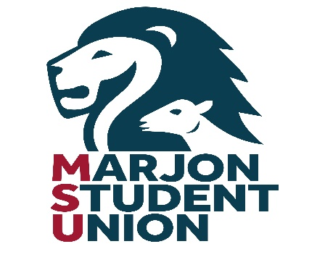

NOMINATION FORM 2024

Candidates Name………………………………………………..

Contact number………………………………………………….

Email ……………………………………………………………..

Nomination for the post of…………………………….....................................................

By submitting this form, I, the aforementioned candidate, hereby declare that I am a current student at Plymouth Marjon University and a full member of the Student Union.

Proposed By 1………….……..…………………..
Seconded 2………………….……………..………
Accepted…………………………….. (candidate)

The following should be a list of sponsors who actively support this candidate in their nomination. All must be full members of Marjon Students’ Union, but not serving officers.

3) 12)

4) 13)

5) 14)

6) 15)

7) 16)

8) 17)

9) 18)

10) 19)

11) 20)

After collecting 20 signatures you need to compose a Manifesto setting out your aims and objectives should you be elected.

I have read and understand the election rules and agree to comply. If running for a sabbatical post I have completed a Trustee eligibility form. Failure to do so could result in sanction or University fine.

Signature…………………………………………date……....................

