Carbon Management Plan 2020-2030

- Carbon Management Plan

Decarbonisation is the term used for the process of removing or reducing the carbon dioxide (CO₂) output of a country’s economy. Currently, a wide range of sectors – industrial, residential and transport – run largely on fossil fuels, which means that their energy comes from the combustion of fuels like coal, oil or gas. The CO₂ emitted from using these fuels acts as a greenhouse gas, trapping in heat and contributing to global warming. By using alternative sources of energy, industries can reduce the amount of CO₂ emitted into the atmosphere and can help to slow the effects of climate change. Decarbonisation has had the most progress in electricity generation because of the growth of renewable sources of power, such as wind turbines, solar panels and technology’s such as the ground source heat pumps we are installing here at Marjon.
In recognition of the climate emergency and responding to student demand, Plymouth Marjon University has committed to reaching net-zero greenhouse gas emissions by 2030. The target is limited to scope 1 and 2 emissions but will also include targeted reductions in scope 3 emissions.
Scope | Direct/ indirect emissions | Source of emissions
Scope 1 | Direct | Emissions associated with sources that are owned or controlled by Marjon. Examples include gas and oil  consumption and from onsite company owned  vehicles and facilities.
Scope 2 | Indirect | Emissions from the generation of purchased electricity.
Scope 3 | Indirect | Emissions from Marjon University’s activities that occur from sources not owned or controlled by Marjon, such as employee business travel, product transport by third parties, outsourcing  of core activities and off-site waste disposal/ management activities, water consumption and procurement related emissions.

Scope 1 & 2 emissions are within the control of an organisation and so the University can effect change that will have a direct impact on emissions, for example through installing photovoltaics to generate electricity. Scope 3 emissions by their nature are outside of the direct control of organisations, such as student and staff commuting.
A table of what emission sources are included in the Carbon Management Plan (CMP) are below:
Scope | Emission sources
Scope 1 | Combined heat & power
 | Solid fuels
 | Gaseous fuels
 | Liquid fuels
 | Vehicle fleet
 | Refrigerant gasses
Scope 2 | Grid electricity
 | Heat purchased
Scope 3 | Water
 | Waste
 | Business hire vehicles
 | Air travel
 | Rail travel
 | Employee commuting
 | Student commuting
 | Procurement related

6.1 Our goals and actions
- To reach this target, the strategies for reaching net-zero carbon in scope 1 & 2 emissions are given below:

- Retrofitting campus buildings to be as efficient as possible. This will happen through the works following the Campus Development Plan, which sets out the development plan for the campus over the course of the next fifteen years.
- Reducing scope 1 and 2 energy waste through engagement campaigns with staff and students.
- Installing alternative heating technologies where viable. For example, this could take the form of further ground source heat pumps or air source heating. A bi-annual review on the feasibility of alternative heating technology on campus will be completed.
- Reducing our electricity demand from switching to energy efficient technology where there is a lifecycle and value for money benefit.
- Increasing production of renewable energy on campus. A bi-annual review of renewable feasibility for the campus will be completed.

- Our strategy for reductions in scope 3 emissions:

- Reducing the amount of waste produced (including that recycled).
- Increasing the rate diverted from general waste to 80%.
- Interim target of at least 60% by 2023.
- Work with Plastic Free Plymouth to reduce our use of single use plastics with annual plastic reduction targets.
- Reducing our mains-water use with behaviour campaigns as well as alternative and efficient technologies.
- Ensuring low-carbon food, including plant-based and locally sourced, is available and promoted.
- Decarbonising business travel with electric vehicle (EV) options and public transport.
- Actively promoting, encouraging, and incentivising low-carbon commuting.
- Transitioning to a pedestrian friendly, less car dominated campus.
- Prioritising long-lasting goods and repairing rather than replacing where possible and practical.
- Divesting from fossil fuels, introducing positive re-investment, and exploring options for ethical banking if viable.

- Our strategy beyond scope emissions:

- Embed sustainability into programmes across all schools of the university.
- Manage the universities grounds to protect and enhance biodiversity.
- Conduct biodiversity surveys to measure progress.
- Engage staff and students with biodiversity and wildlife campaigns, such as Hedgehog Friendly Campus
- Create opportunities for the universities community to be involved in environmental improvements on campus.
- Annual sustainability report to monitor progress on the sustainability strategy.

6.2 Summary of emissions to date
The Marjon community has consistently agreed to an aim of net-zero carbon or equivalent emissions by 2030. Definitions for this vary, but Marjon is committing to reaching net-zero greenhouse gas emission that we directly cause (scopes 1 & 2). Marjon is already seeing an 80% reduction in CO₂ compared to our 2005 baseline, and in the last ten years, Marjon’s direct emissions have been cut by approximately 60%, and the University wants to continue this trend to zero over the next ten years. Beyond this, Marjon is committed to making heavy reductions in indirect emissions (scope 3), while recognising that at this point in time it is not possible to completely eliminate them.

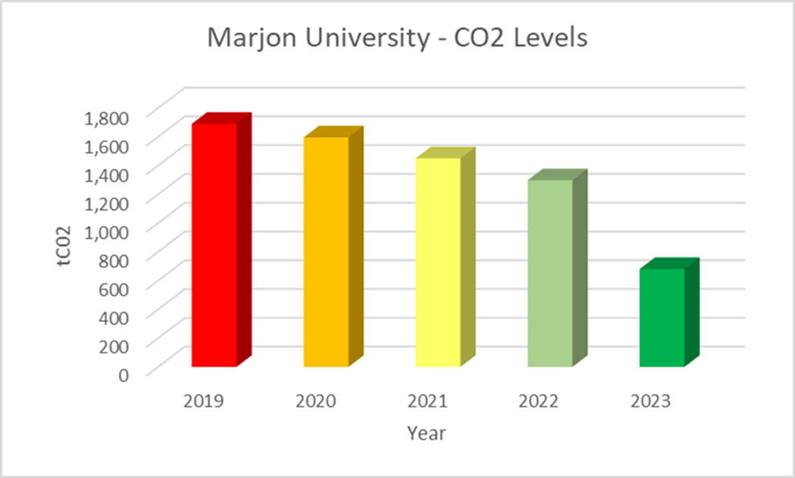
Figure 1- Graph to show Marjon’s CO2 levels to date, with predictions for Marjon’s 2022 &2023 levels.

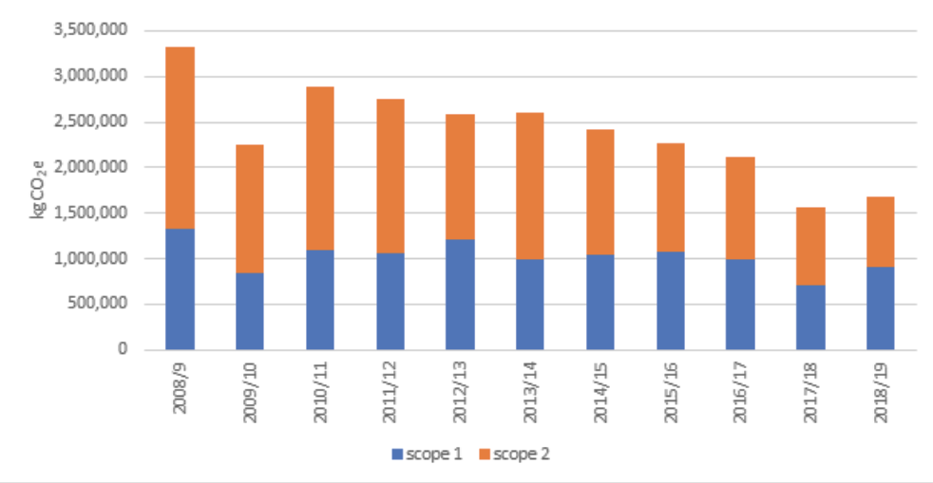
Figure 2- Graph of the carbon equivalent emission produced by Marjon Universities use of gas (scope 1) and electricity (scope 2).

6.3 Carbon Reduction Projects to date
Since Marjon declared a climate emergency in 2019, the university has made a lot of progress in decarbonising the campus with trail blazing initiatives.

- Solar Panels

In 2020, Marjon University received £700k of funding in the Salix round 1 bid (part of the Public Sector Decarbonisation Scheme). This funding allowed the university to install 2,114 new solar panels on our campus roofs, install over 3,000 new LED lights, a new Building Energy Managements system and new transformers. These projects will allow us to see a saving of ~300 tonnes of CO₂ e per year.
The installation of solar PV panels was an integral part of Marjon’s decarbonisation plan. The strategy aims to decarbonise the estate through a holistic approach that looks at every aspect of energy use across the campus. As the University progresses with its 2020 Campus Development Plan, we plan to refurbish every building and improve the thermal efficiency, significantly reducing the heating load. Underpinning this is a 5th generation district heat network which draws its energy from ground source heat pumps. This creates the foundations for the University's transition to a low/zero carbon campus. The gas supplies and boilers will be replaced with ground source heat pumps, moving the whole campus onto electric and away from gas.
With the move away from gas to electric it is necessary to generate carbon free electricity on-site. The solar photovoltaic system brings over 800 kWp which will go into powering the majority of our new ground source heating system, shifting the heating of the campus away from fossil fuels and onto renewable electricity.
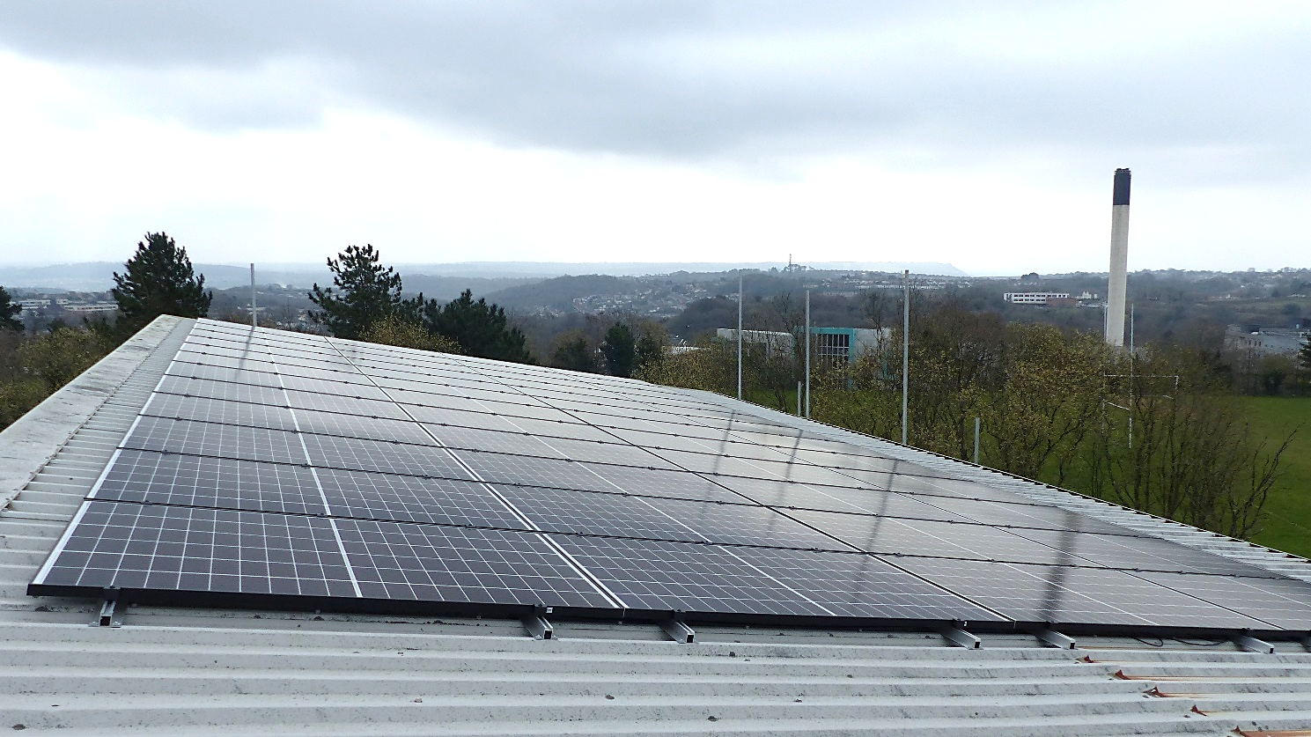
Figure 3- Image of one of the solar panel arrays on Marjon’s roof tops.
Marjon Solar PV Installation Savings:

- LED light replacements
LED lighting is an attractive, eco-friendly and cost-effective alternative to traditional lighting. With Marjon installing over 3,000 new LED lights, this will save the University 56.05 tonnes of CO₂e per year. New LEDs have been installed into our East Block, HDC, Hudson Halls, The Chaplaincy, Library & Sports Centre.

Marjon LED Lighting Installation Savings:

Another benefit of installing LEDs is the mental health impact it can have. Regular lights have been used to treat S.A.D (winter blues) but LED lighting is most effective as it is made out of light (mimicking natural light), not heat, which is what the people with this disorder need. Regular lights need 90% heat to produce light, making up only 10% of light. Having LEDs in classrooms will improve student and staff focus, helping the university rooms to be a more enjoyable place to be.
As the University continues to decarbonise, it will become increasingly important to not leave any stone unturned and ensure we are looking at every aspect of our energy use. University lighting is a large proportion of any university’s energy use. We have made the initial steps to switch the majority of our lighting to LEDs, but to reach net-zero carbon by 2030 we must continue to change all lights on campus.
The best solution to reduce our energy demand from lighting is a combination of switching to LED lighting in combination with reducing the demand for lighting through strategic building design within new builds, and a smart lighting control e.g. motion sensors/ timers throughout all our buildings.
Although there are many factors to consider when designing a building to take maximum advantage of daylight, it will be an important step to ensuring any new builds are net-zero from the start by decreasing energy demand. With LED lighting reducing energy demand, and daylight control in combination with installation of motion sensors seeing a further reduction, there should be the potential to see a significantly decreased lighting energy demand campus wide with these measures in place.
The aim is to switch the entire campus to LEDs by 2030, along with smart motion sensor lights in appropriate areas.
With any new build construction, the buildings will be designed from the off with daylight control as top of the lighting energy demand agenda as a form of ‘free’ and zero-carbon method of lighting the building. This strategy will be in conjunction with the LED lights installation and smart motion sensors and lighting control technologies.

- New Building Energy Management System
In 2020 Marjon University installed a new Building Energy Management System (BEMS). This was funded through the phase 1 of the Salix bid funding. A Building Energy Management system is a sophisticated method to monitor and control the building's energy needs.
In the UK, the domestic sector represents about 28% of CO₂ emissions and within that space heating is 53%, lighting and appliances 22%, and water heating 20%, showing the importance to improve building efficiency.

Benefits of the new Building Energy Management System (BEMS)
Optimisation of building and plant operations
Provision of energy management information
Remote monitoring and control of services and functions of one or several buildings
Possibility of automatic control of services and functions. For instance, automatic switch-on, switch-off of appliances
Monitoring of building status and environmental conditions

Marjon’s Building Energy Management System installation Savings:

BEMS System upgrades were required to enhance controls associated with heat decarbonisation, identified as part of a Marjon’s medium-term decarbonisation strategy. This focus has been driven by the following factors:
- The buildings are multi-use, high energy consuming facilities. Optimising heat efficiency is a central component of our long-term decarbonisation plans. For multi-use buildings, a dynamic system which gives granular control of thermal loads is essential to optimise efficiency and reduce carbon consumption associated with heating and cooling. As part of the University's post-Covid strategy, Marjon has been reviewing space utilisation and will require a flexible and dynamic approach to resource allocation and this in turn requires a dynamic controls system. As new operating models emerge in coming months and years, the new BEMS offers a flexible and dynamic controls system to manage thermal energy consumption.

- Marjon’s old BMS system was operationally defunct and had therefore reached the end of its life. It could not provide the granular measurement and controls required to optimise energy in a dynamic mixed-use building.

- Utilisation of the new BEMS system and managed diagnostics platform will achieve a 14% energy use reduction for existing buildings. The system also provides integration opportunities through open protocols, new data management techniques and open architecture providing ability to lower fuel consumption and costs through an integrated approach with other building systems. The leverage of existing technology to achieve greater cross-system communication will support greater efficiencies in its holistic form, resulting in energy conservation, and a decrease in the demands for operation management and user processes.

- As high footfall buildings at the heart of our teaching facilities, the new BEMS gives an opportunity to present end user dashboards aimed at educating building users on how their behaviour impacts on reducing the carbon burden of building operations. Graphical displays based on real time carbon emissions can be presented in central areas on display screens or by web interface to any device. The objective is to drive awareness and give ownership of energy usage and wastage to students and staff to involve them in the carbon reduction narrative. These end user dashboards give an additional opportunity to introduce gamification into the carbon reduction agenda.

- Transformer Updates:

In 2020 we also used funding from the phase 1 of the Salix bid to upgrade our 1960s/1970s vintage transformers that did not meet current efficiency standards. Working with Schneider Electric, 3 units were identified to be replaced in order to significantly lower the carbon costs without intrusive structural work.
They were identified as potential high loss units and replacing them with low loss transformers was an iterative component of our decarbonisation strategy.

Marjon Transformer Upgrades Savings:

- EV Charging Points
In 2019 Marjon installed 10 new EV changing points. These are available for both staff, students and visitors to use. These were installed as part of Plymouth City Councils successful bid to the Transforming Cities Fund (TCF) to have £200,000 available for organisations across the city to use. Marjon won a pot of this funding as part of the Workplace Charging Grants.
In the last year alone, we have saved roughly 295.4kg of CO₂e through people charging their cars on campus rather than filling their car with traditional fuels.

EV Charge Points Usage Data
Month | kWh Consumed
April 2021 | 26.976
May 2021 | 79.569
June 2021 | 0
July 2021 | 85.496
August 2021 | 27.193
September 2021 | 190.175
October 2021 | 478.292
November 2021 | 808.836
December 2021 | 503.531
January 2022 | 613.992
February 2022 | 502.171
March 2022 | 986.993
April 2022 | 506.400
Total: | 4,809.624

We can see that over the last 12 months, uptake of the EV charging points has increased significantly

- Ground source heat pump installation
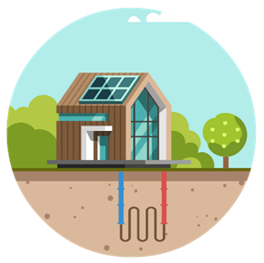
In 2022, Marjon University finished installing 55 ground source heat pumps (GSHPs) (120 bore holes) across campus. These GSHPs now power our main educational buildings, student village and staff houses. This project was carried out due to winning £3.5 million of funding during the phase 2 of the Public Sector Decarbonisation Scheme.
A GSHP powered heating system network was identified as the most effective way to achieve zero carbon heating system for the campus during the work undertaken as part of the University's Campus Development Plan. This has since been further backed up by work undertaken from the Low Carbon Skills Fund and also by Kensa Contracting (a Southwest based GSHP company that is the current UK market leader).
The GSHP installation is the foundation for the University's transition to a low/zero carbon campus. The gas supplies and boilers will be replaced with ground source heat pumps, moving much of the campus onto electric and away from gas.
The project encompassed the installation of a low temperature heating system powered by ground source heat pumps, in the North, West and South Blocks of the Quad and 45 residential dwellings on the campus.

Environmental benefits of GSHPs:
- GSHP's last longer than traditional heating or conditioning systems (25-year lifespan).
- The process is sustainable, with ground heat being inexhaustible.
- A GSHP can deliver 3-4kW of heat for every 1kW of electricity used.
- Electricity will be provided by onsite solar panels.

If more of the boilers were nearing the end of their life, the plan would be to shift every building away from gas, but these will be picked up when the buildings are refurbished.

- Upgraded Loft Insulation:
As part of the GSHP installations, a survey was also done to determine which, if any, of the buildings that are switching to GSHPs require updated loft insulation. The student village and staff houses were identified as requiring these updates and therefore saw 300mm loft insulation installed in 2022.
A quarter of heat is lost through the roof in an uninsulated home. Having efficient roof insulation is an effective way to reduce heat loss and reduce heating bills. It was important to update any inefficient loft insulation in conjunction to the GHSP projects as to reach net-zero carbon, we must target reductions in both energy demand as well as making the energy we do use ‘greener’.

