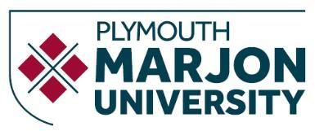

Applying for a Speech & Language Therapy Course

Qualifications
Check you have the correct entry qualifications. If you’re unsure, please contact the
Admissions Office for advice.

Personal Statement
Your personal statement should be well written and show a good understanding of a Speech & Language Therapist’s role. It’s important to explain the reasons for choosing SLT as a profession (you can look at the Royal College of Speech and Language Therapists website for information). We look for people who have some experience (e.g. voluntary) of working with people who have communication difficulties. It is difficult to get this kind of experience within the NHS however there are a number of organisations with local branches who may welcome volunteers (for example Connect, Headway, Stroke Association, Parkinson’s UK, National Autistic Society, Afasic and Sense).

Qualifications
You will be expected to have a range of GCSEs at Grade C or above. This must include grade B in GCSE English Language and grade B in Mathematics or Science.

We require ABB at A level and these must include one of the following subjects; English Language, Psychology, or Biology. General Studies is not accepted. We will consider applicants with a BTEC distinction at level 3 if this is offered in combination with at least 2 A levels.

We are pleased to consider applications from Access to HE students and require 45 credits at level 3 which should include 30 distinctions and 15 merits. Subjects should include Biology and Psychology.

Research
Royal College of Speech and Language Therapists (RCSLT) http://www.rcslt.org/
All applicants should apply via UCAS and this should be submitted by 15th January
We will try to offer you an alternative course if you are unsuccessful with your application.

If you have any queries, please contact our Admission Team at admissions@marjon.ac.uk or on 01752 636 890. You may also find our website useful at www.marjon.ac.uk

