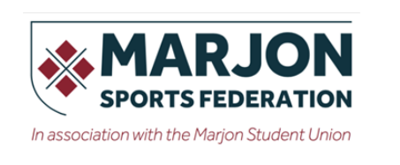 | 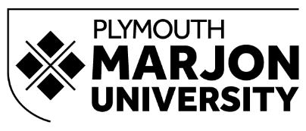

Social Media Guidelines for Marjon Sports Federation
As members of the Marjon Sports Federation (MSF) you are an ambassador and a role-model.
Play by the code of conduct when using social media.

The code requires that you:
- Consider the well-being and safety of others.
- Develop relationships based on mutual trust and respect.
- Promote the positive aspects of the sport (e.g. fair play).
- Display consistently high standards of behaviour.
- Act in a responsible manner in relation to the content of personal websites and/or information posted on sites such as Facebook, Twitter and YouTube.
- Never condone rule violations or rough play.
- Never be unduly intoxicated or use any illegal drug whether sporting or recreational at any event or social function organised under the umbrella of the Club, MSF or PMU.
- Never discriminate or condone discrimination or bullying of any kind within the MSF and do not encourage or pressure others into acting against the code.
- Respect club coaches and officials including match day referee’s.

Translated to social media this means:
- Always be respectful when referring to team mates, match officials and opposition teams.
- Sport at Marjon is inclusive - do not post anything that excludes by gender, race, sexuality, disability, or is abusive.
- Uphold fair play.
- Do not to use degrading or threatening language towards anyone. Cyber-bullying of any kind will not be tolerated. No ‘smashing them’ and no ‘scum’.
- Get written photo permission for your players – if someone opts out then respect that. If taking photos of the opposition then ask if that is OK.
- Avoid banter and in-jokes - people you don’t know will take your words in ways you don’t expect, with unanticipated consequences.
- No posts referring to alcohol and/or drugs.
- If someone asks you to edit or remove a post, just do it.
- Be wary of liking or sharing posts with potentially offensive content, including offensive language. Remember you are an ambassador and role-model for PMU.
- Send the names of the Account Manager, other administrators and the password to the marketing team to socialmedia@marjon.ac.uk.
- Ensure that account profile information clearly states the purpose of the account and the hours during which it is monitored.
- Ensure that the social media account is kept up to date, posted from frequently and questions responded to promptly within operating hours.

